🧹 AWS Orphaned Resources Detection & Cleanup – Complete SOP (Enhanced)

📌 1. Overview
🧠 What are Orphaned Resources?
Orphaned resources are AWS resources that:
- Are not attached to any service ❌
- Still incur cost 💰

🔥 Common Examples
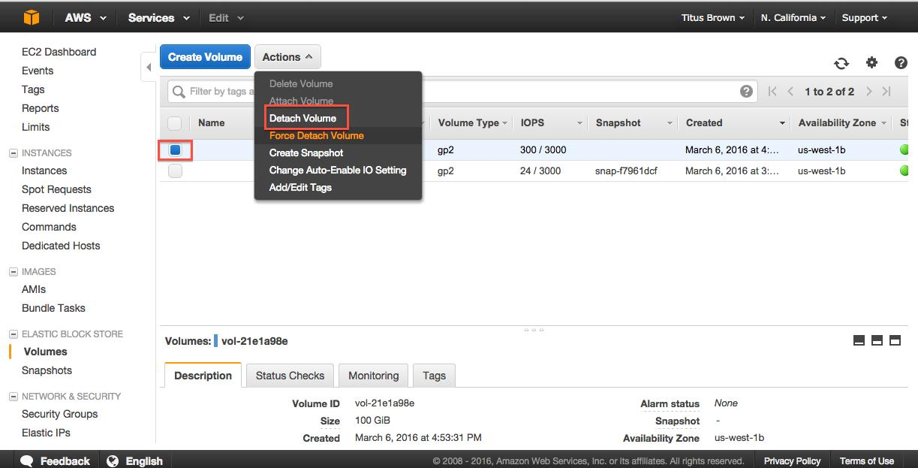
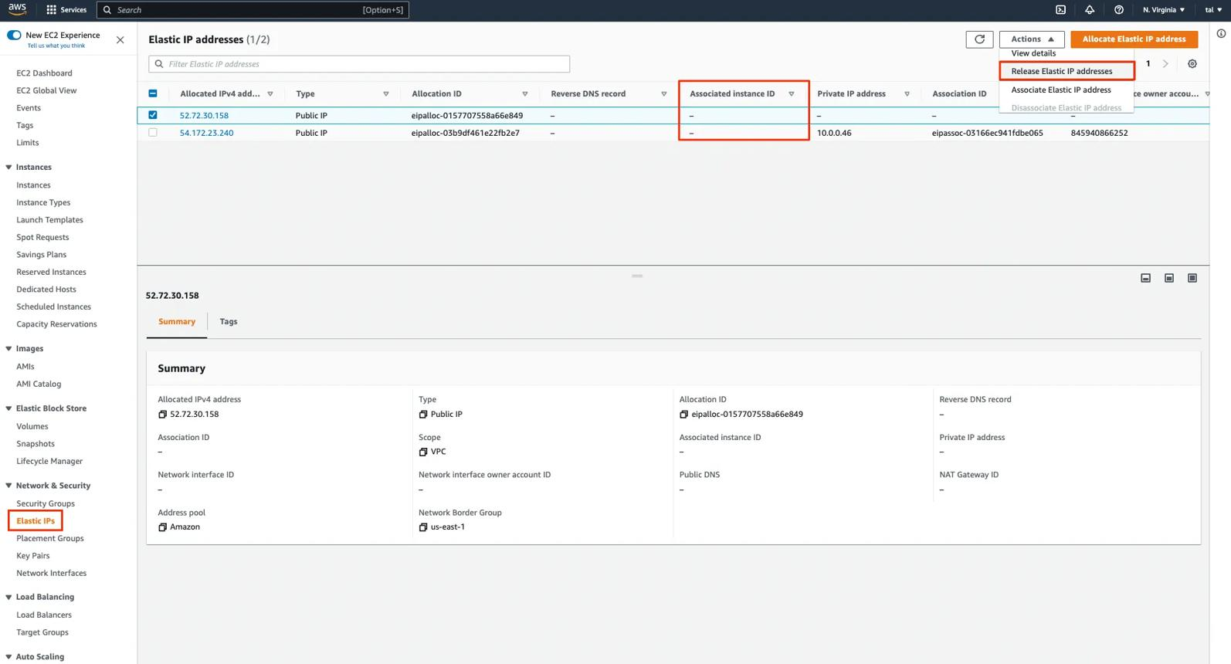
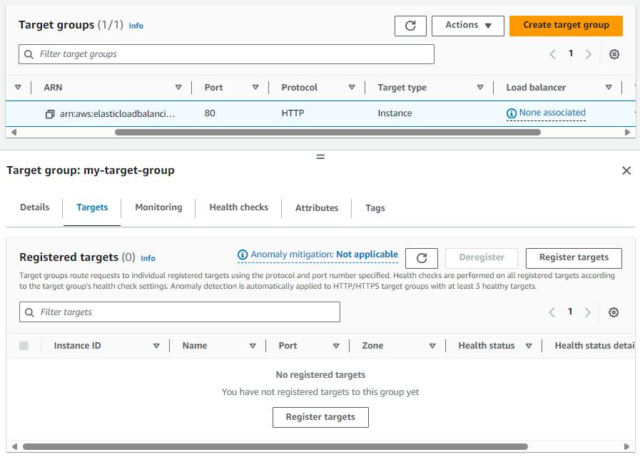
6
- Unattached **Amazon EBS volumes
- Unused Elastic IPs
- Idle Load Balancers
- Old Snapshots
- Unused Security Groups

🎯 2. Objective
- Identify unused resources
- Reduce unnecessary cost
- Maintain clean AWS environment

🧭 3. Methods Covered
Method | Tool
Cost analysis | AWS Cost Explorer
Recommendations | AWS Trusted Advisor
Manual checks | EC2 / EBS / ELB
Compliance tracking | AWS Config
Automation | AWS Lambda + Amazon CloudWatch

🧪 METHOD 1: Cost Explorer (Cost Analysis)

🖼️ Console View
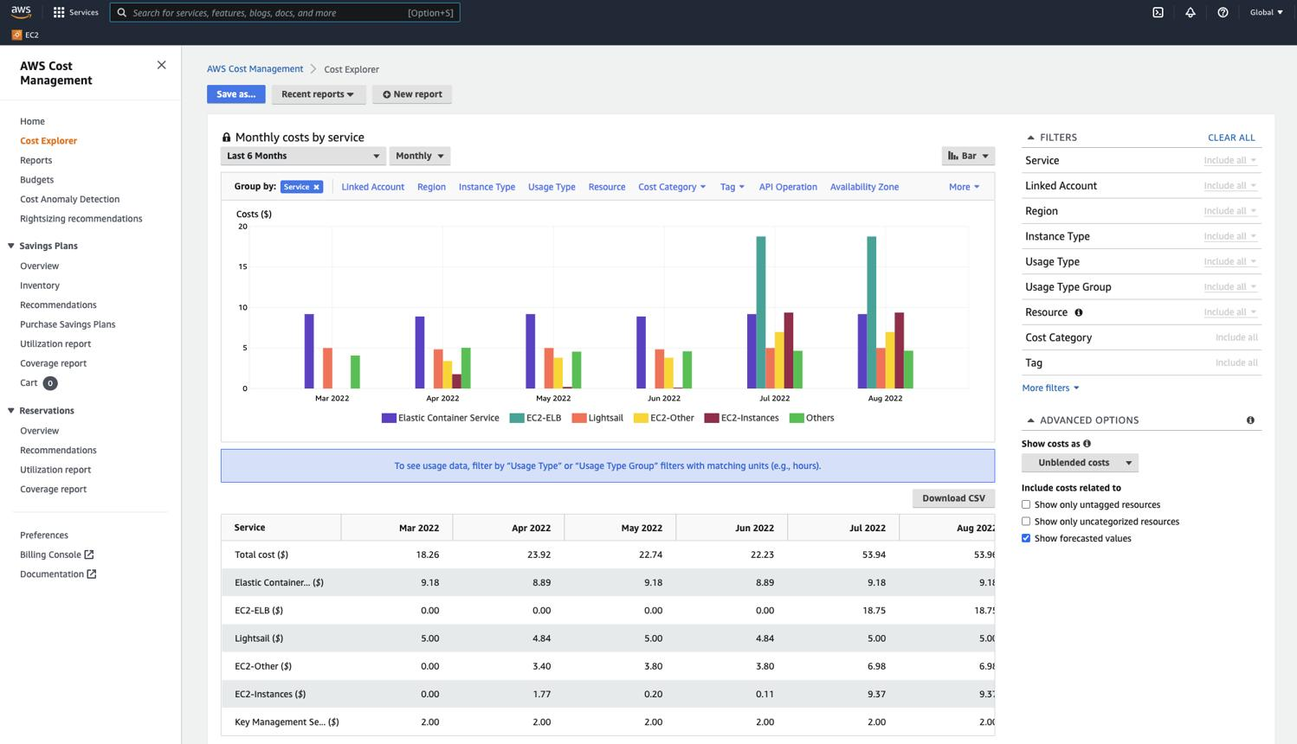
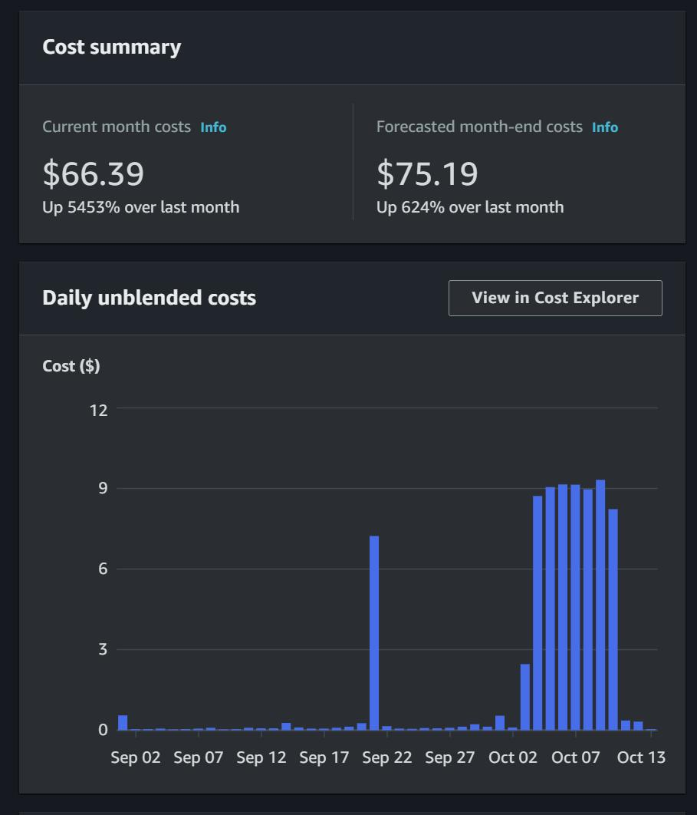
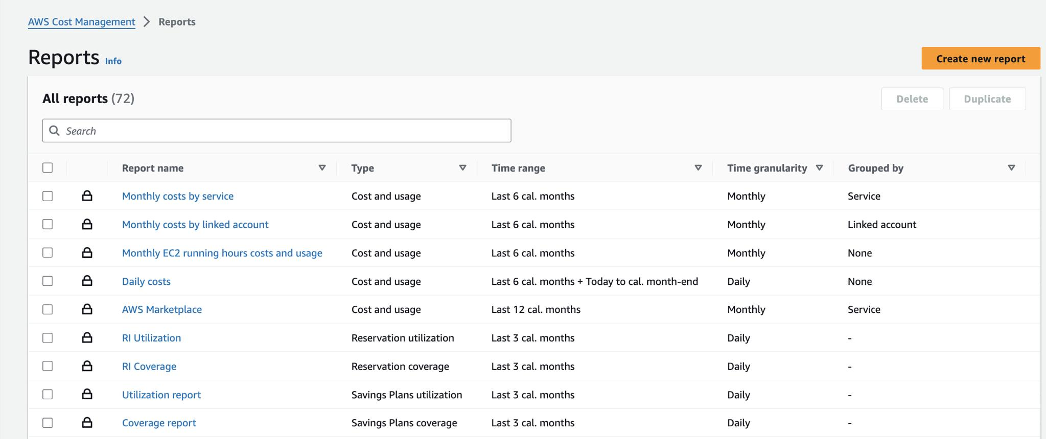
5

🔧 Steps
- Go to AWS Console → AWS Cost Explorer
- Select:
  - Monthly cost
- Group by:
  - Service
- Analyze usage trends

🔍 What to Look For
- High EBS cost but fewer EC2 instances
- Sudden cost spikes
- Idle services still billing

🧪 METHOD 2: Trusted Advisor (Recommendations)

🖼️ Console View
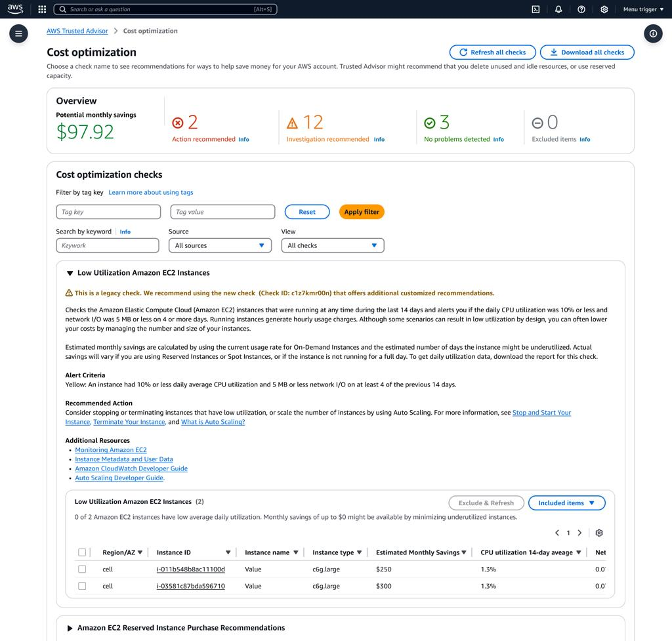
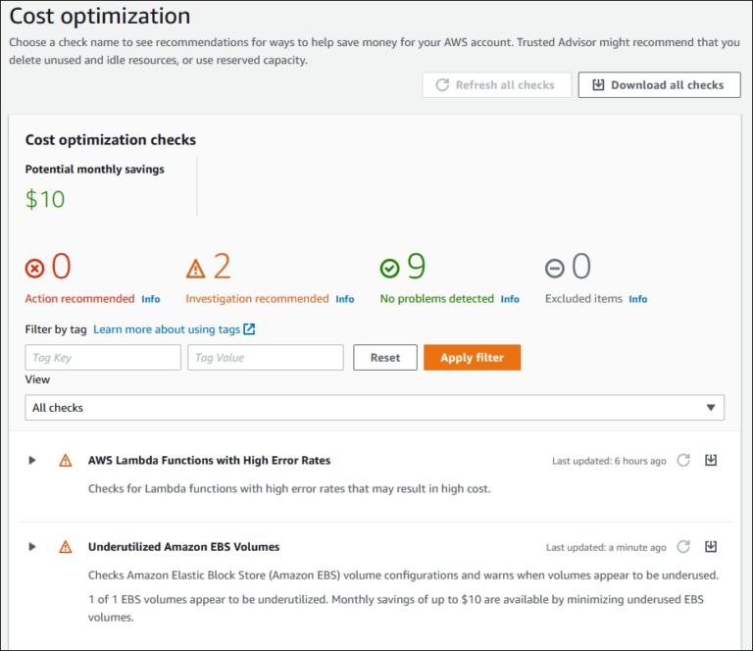
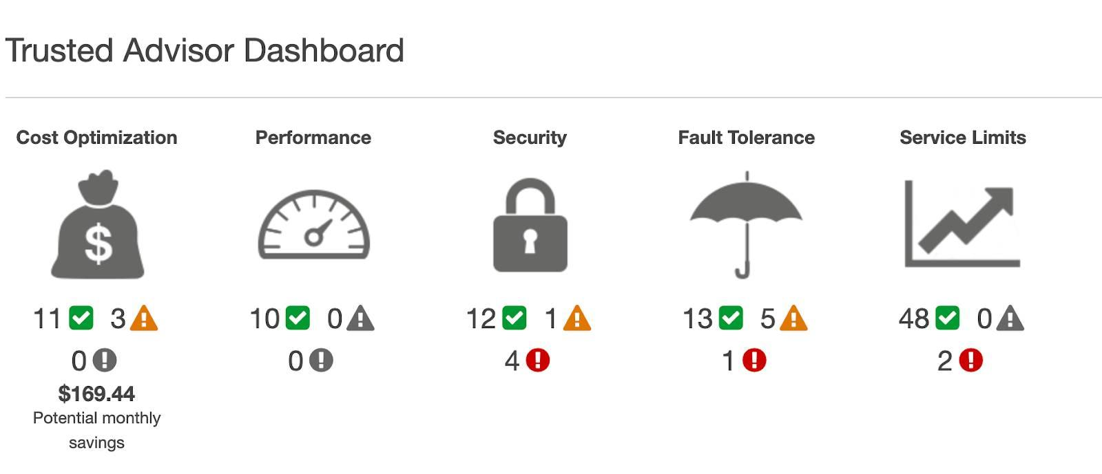
6

🔧 Steps
- Open AWS Trusted Advisor
- Go to:
  - Cost Optimization
- Review checks:
  - Idle Load Balancers
  - Unused Elastic IPs
  - Underutilized EC2

💡 Why this matters
👉 Quick way to find low-hanging cost issues

🧪 METHOD 3: Manual Checks (MOST IMPORTANT)

🔹 3.1 Unattached EBS Volumes

🖼️ Reference
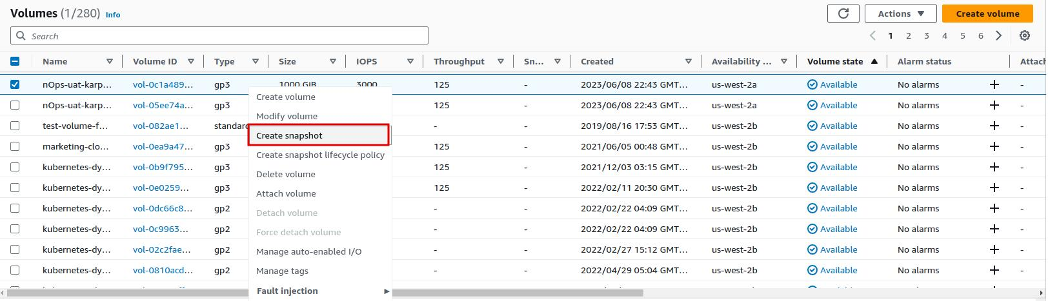

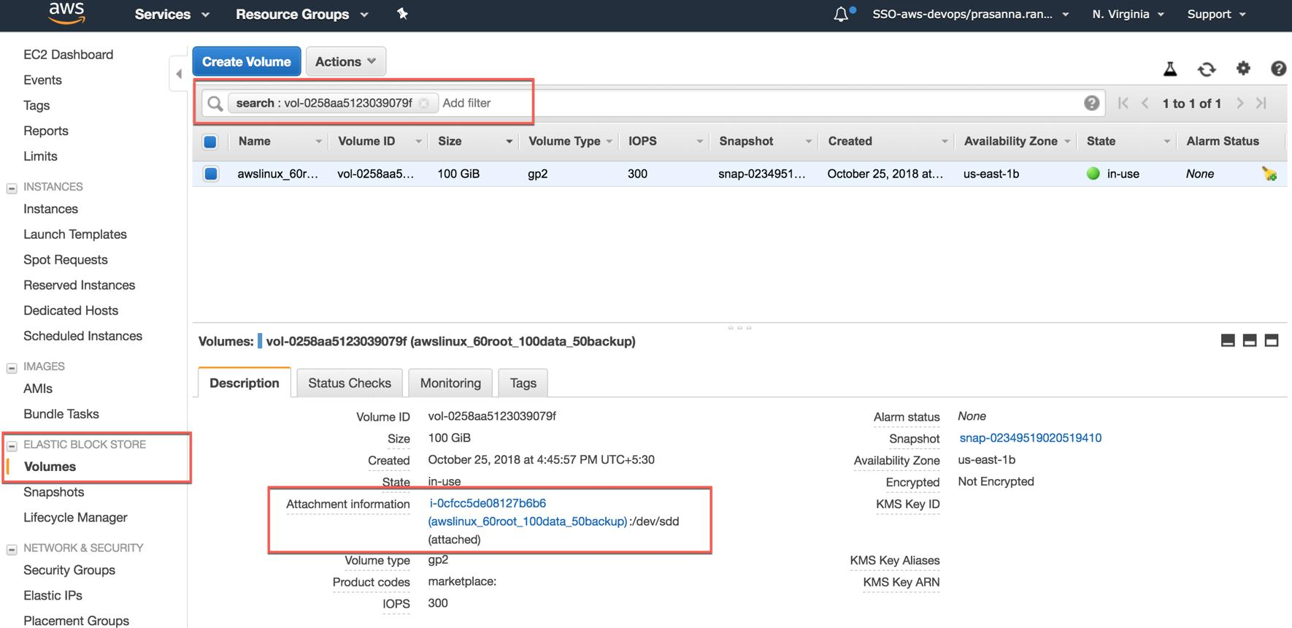
6

🔧 Steps
- Go to EC2 → Volumes
- Filter:
  - State = Available
👉 These volumes are not attached but still costing money

🔹 3.2 Unused Elastic IPs

🖼️ Reference

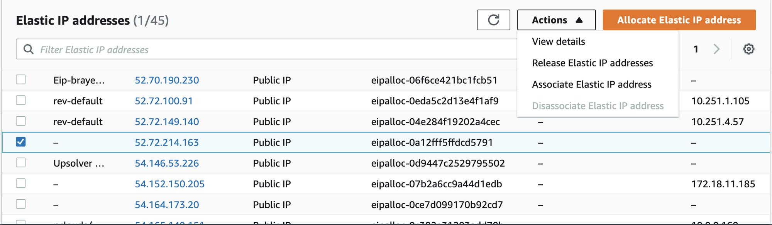
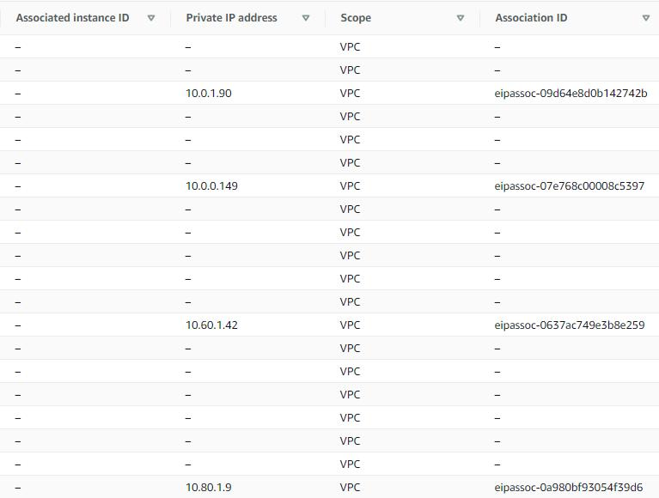
5

🔧 Steps
- Go to EC2 → Elastic IPs
- Check:
  - Not associated
👉 AWS charges for unused Elastic IPs

🔹 3.3 Idle Load Balancers

🖼️ Reference

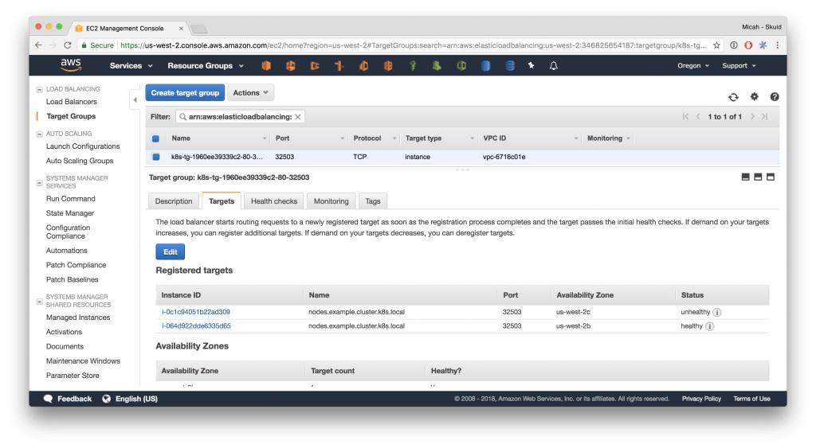
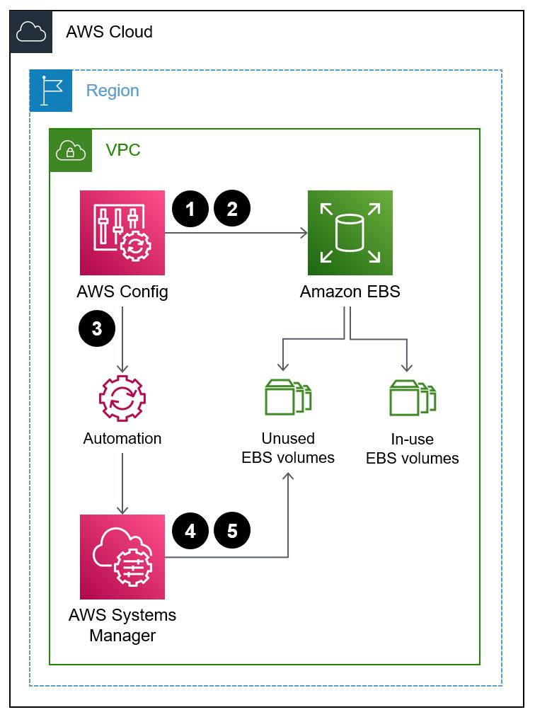
5

🔧 Steps
- Go to EC2 → Load Balancers
- Check:
  - No registered targets

🔹 3.4 Old Snapshots

🖼️ Reference
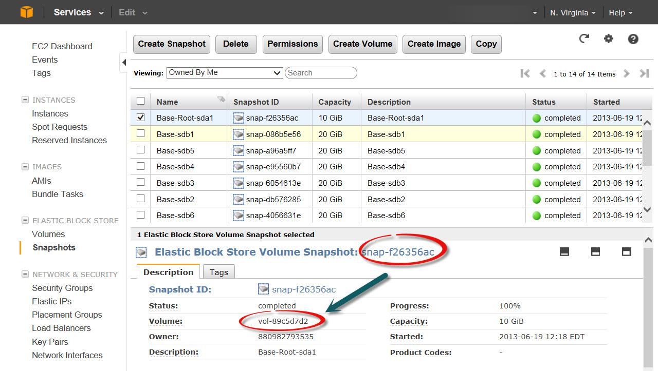
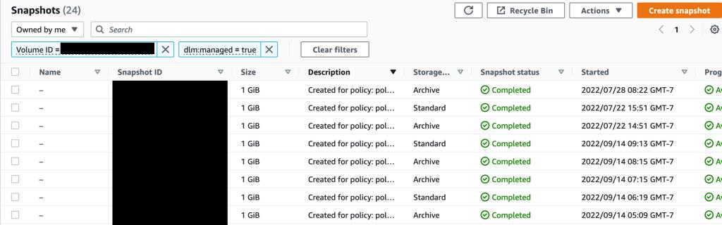
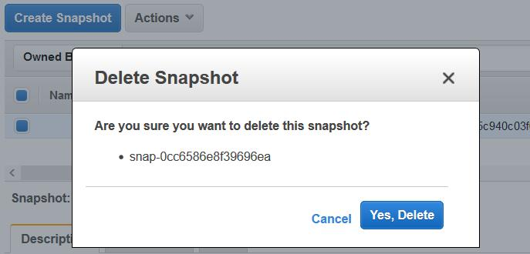
5

🔧 Steps
- Go to EC2 → Snapshots
- Sort by date
- Identify unused/old snapshots

🔹 3.5 Unused Security Groups

🖼️ Reference
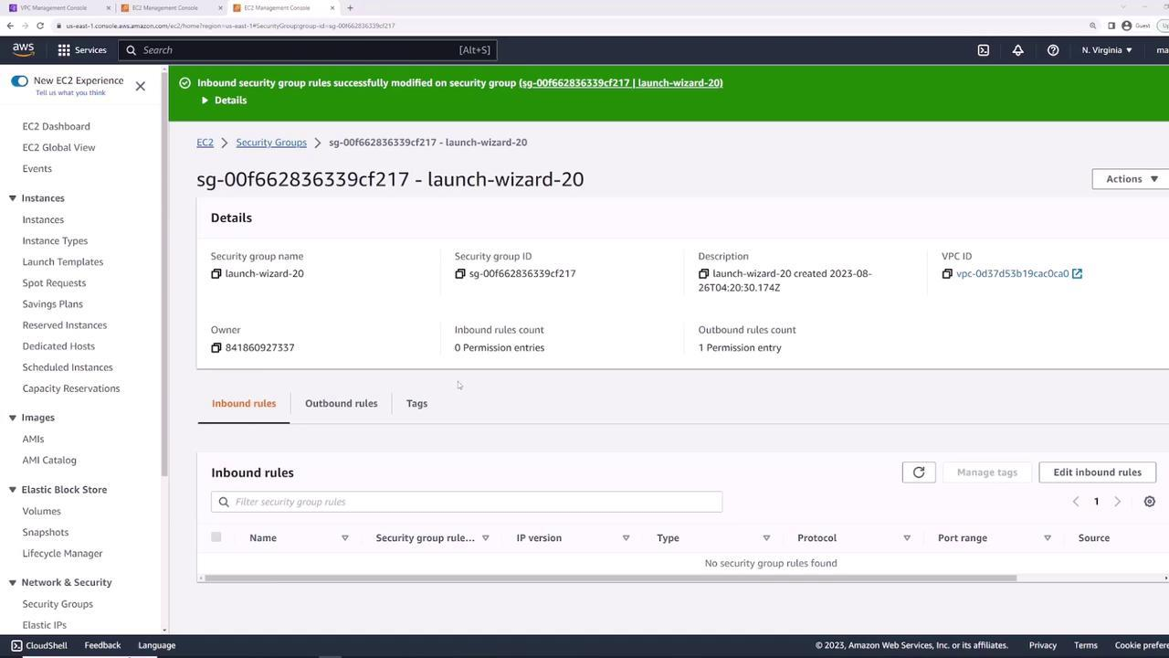
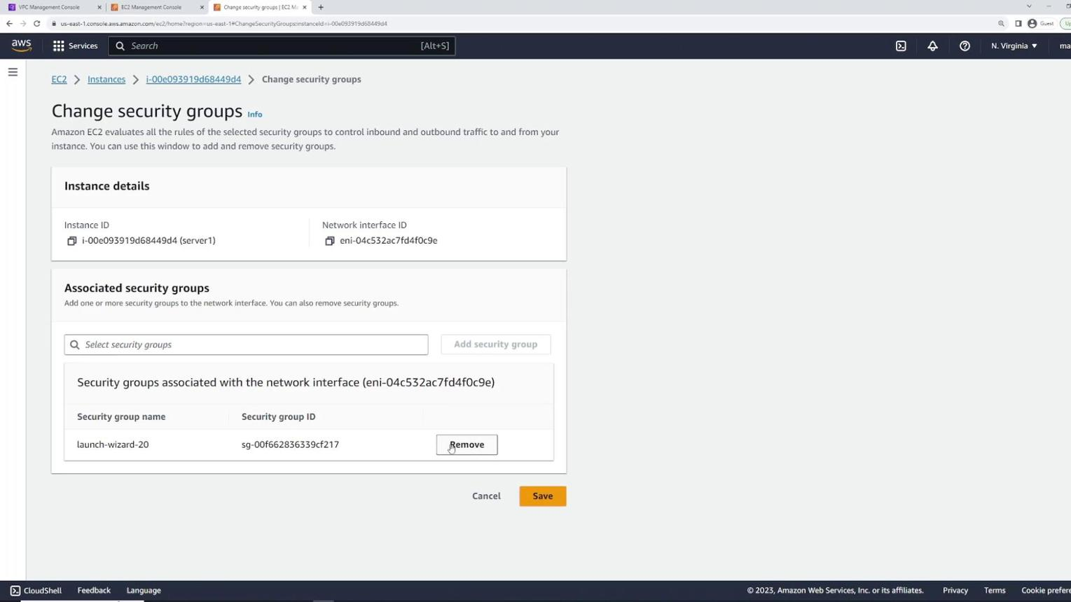
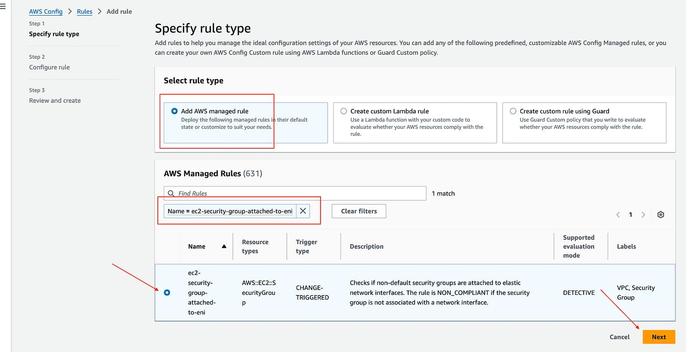
6

🔧 Steps
- Go to EC2 → Security Groups
- Identify groups not attached to any resource

🧪 METHOD 4: AWS Config (Continuous Monitoring)

🖼️ Reference
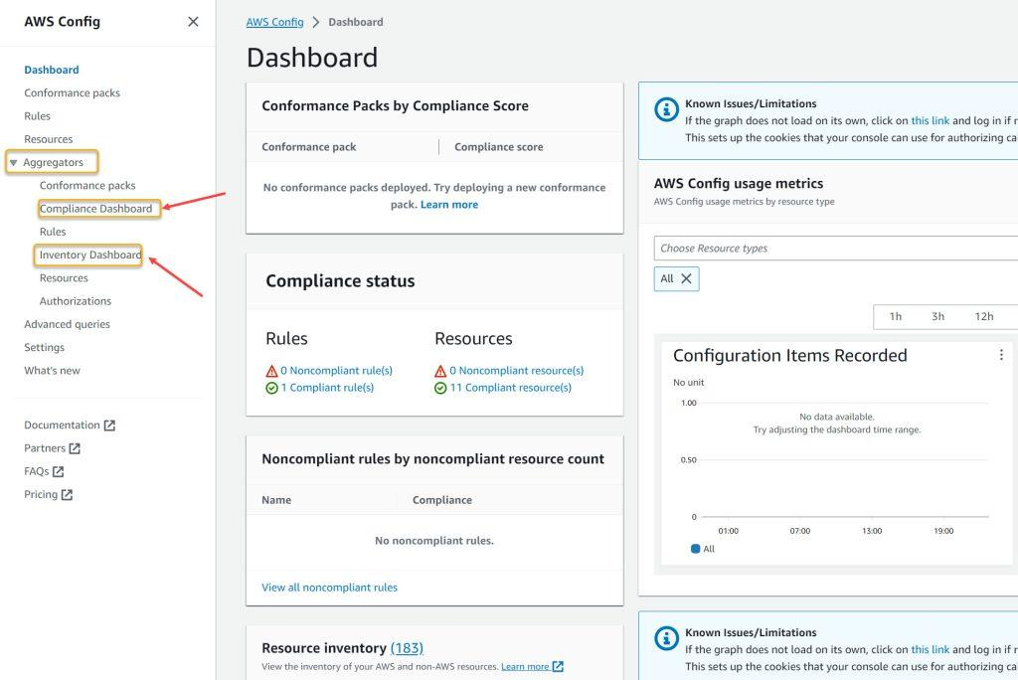
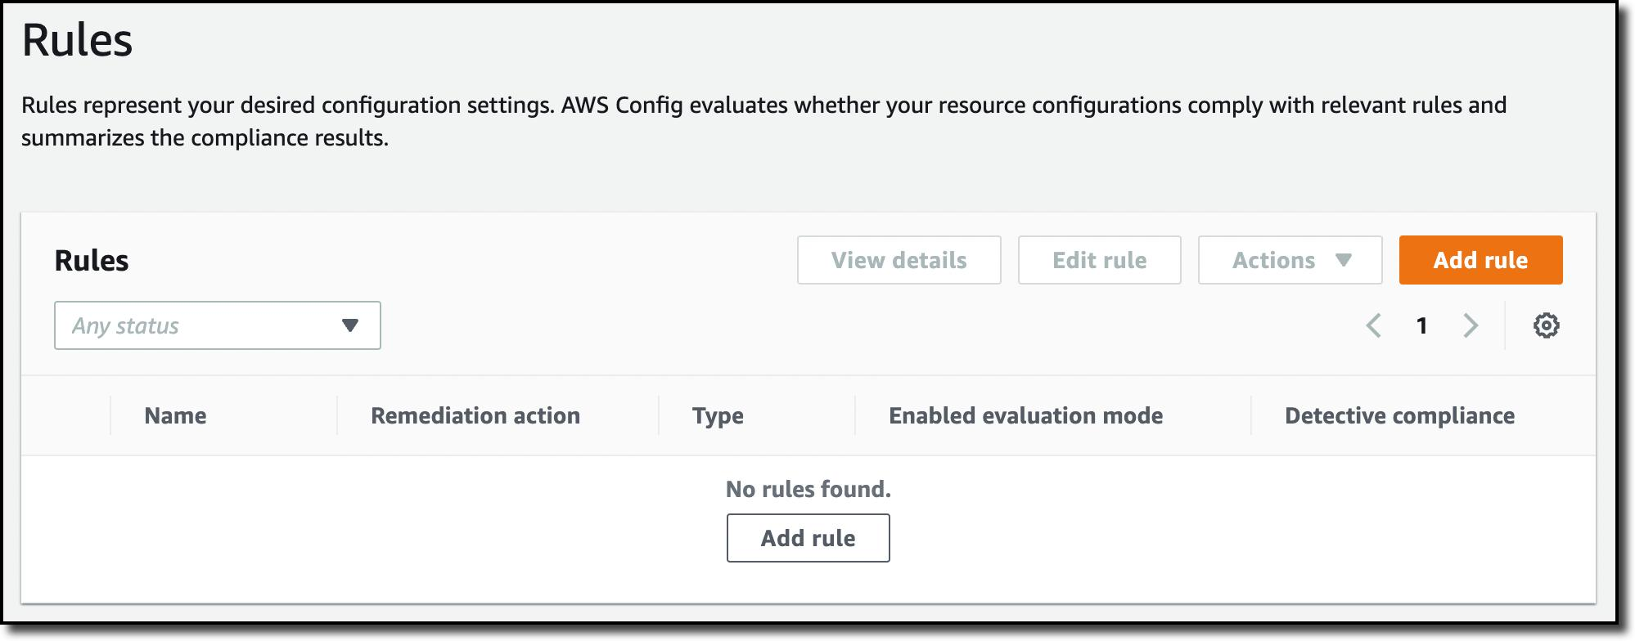
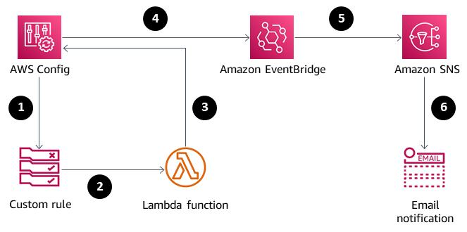
6

🧠 What it does
👉 AWS Config continuously monitors resources

🔧 Steps
- Go to AWS Config
- Enable Config
- Go to Rules → Add Rule

Example Rules
- EBS volume must be attached
- Security group should not be unused

🔥 Benefit
- Continuous detection
- Compliance tracking
- Alerts for violations

🧪 METHOD 5: Automation (Lambda + CloudWatch)

🖼️ Reference
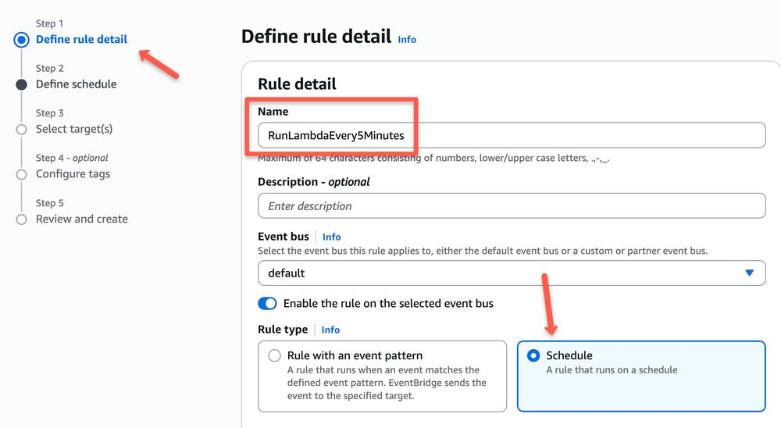
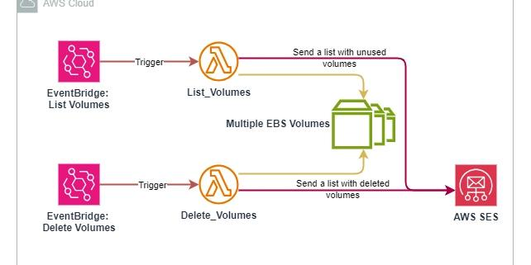
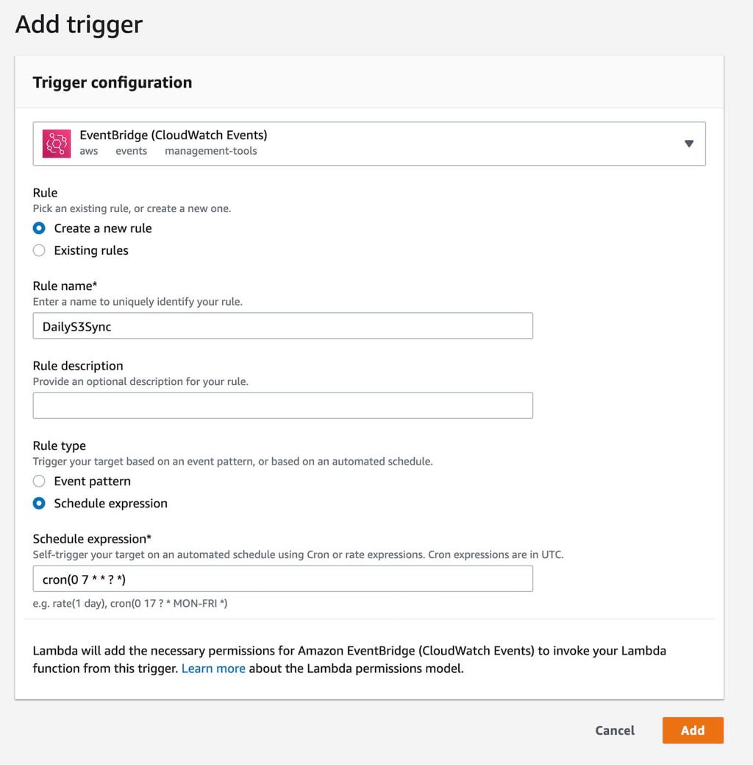
7

🧠 Idea
Automate cleanup process

🔧 Steps
- Create **AWS Lambda function
- Add logic to:
  - Detect unused EBS
  - Detect unused EIPs
- Create Amazon CloudWatch rule
- Trigger Lambda periodically

🔥 Optional Enhancements
- Send alerts using SNS
- Auto-delete unused resources

🔍 4. Final Checklist
Resource | Condition
EBS | Available
EIP | Not associated
ELB | No targets
Snapshot | Old
SG | Not attached

🎯 5. Best Practices
- Tag resources properly
- Enable billing alerts
- Review monthly
- Automate cleanup
- Use AWS Config for governance

🎯 6. Interview Answer (Perfect Version)

🗣️ Answer
“To detect and clean orphaned resources in AWS, I use multiple approaches.
First, I analyze cost using Cost Explorer to identify unusual spending.
Then I use Trusted Advisor for recommendations like unused Elastic IPs and idle load balancers.
I also perform manual checks such as unattached EBS volumes, old snapshots, and unused security groups.
For continuous monitoring, I use AWS Config, and for automation, I implement Lambda with CloudWatch to detect and clean unused resources periodically.”

🔥 Real-World Tip (Very Important)
“Stopping EC2 does NOT stop EBS billing — which often leads to orphaned volumes.”

🏷️ Tags
AWS Cost Optimization AWS Config Automation DevOps

